WEB HOSTING FROM S3

Amazon Simple Storage Service (S3) is a cloud storage service provided by Amazon Web Services (AWS). Web hosting from Amazon S3 is a service that allows users to store and serve static website files directly from Amazon Simple Storage Service (S3), a highly scalable object storage service offered by Amazon Web Services (AWS).

* First step is to create bucket – here I’m creating a bucket by the name of samplewebpag , while creating don’t block the public access as the public access is needed to host a website.

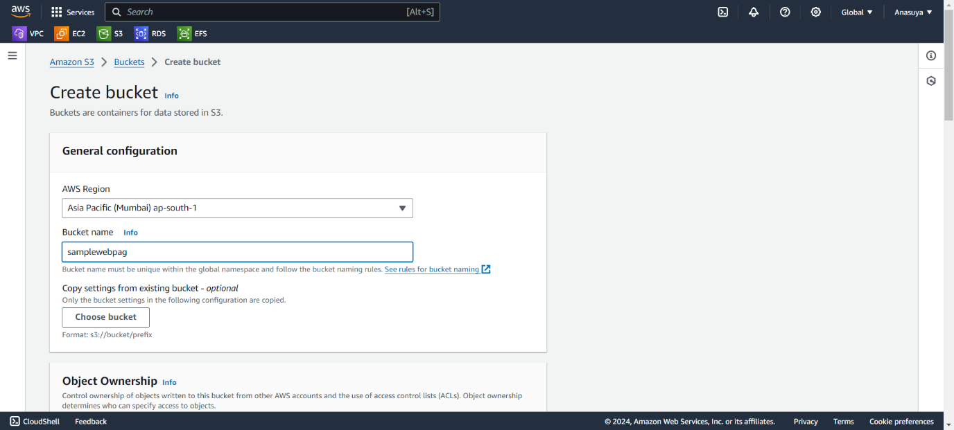

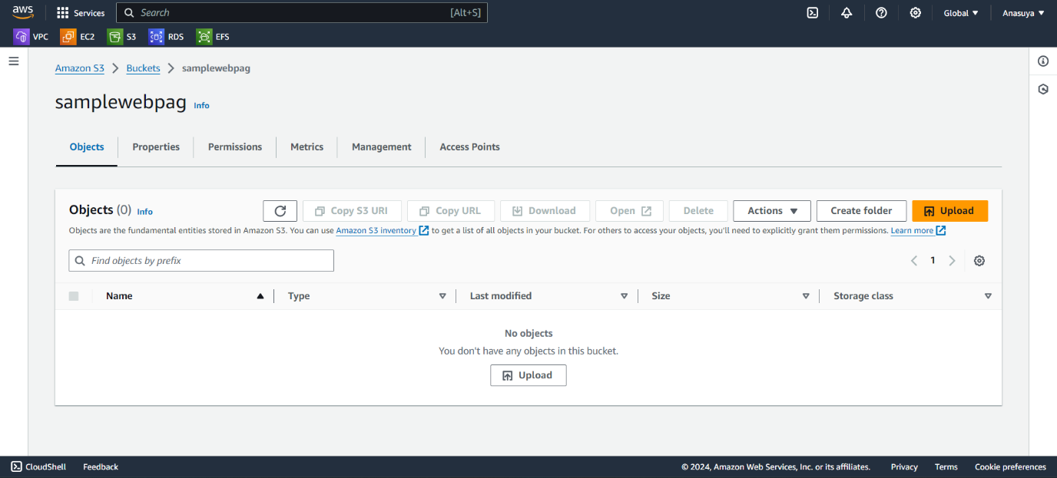

* Then go to upload and add files and folders of your static web application html file

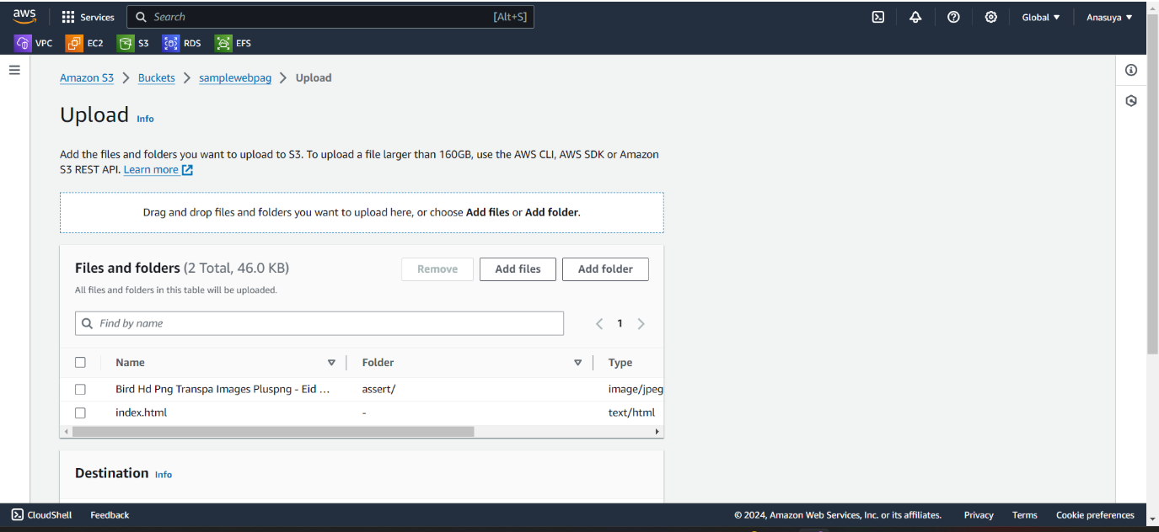

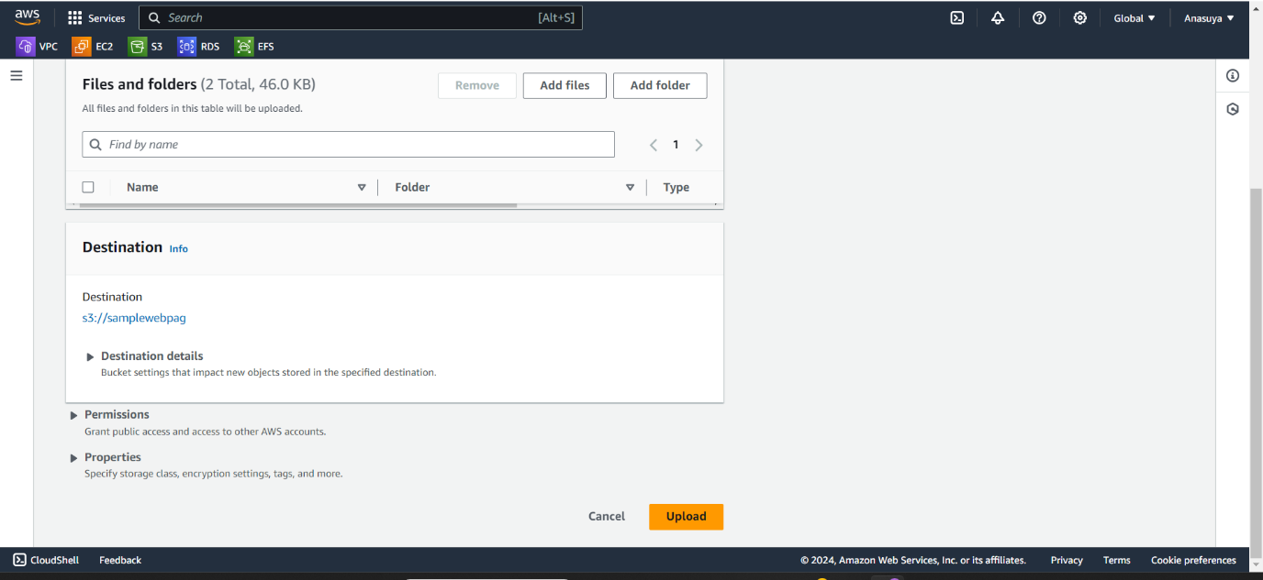

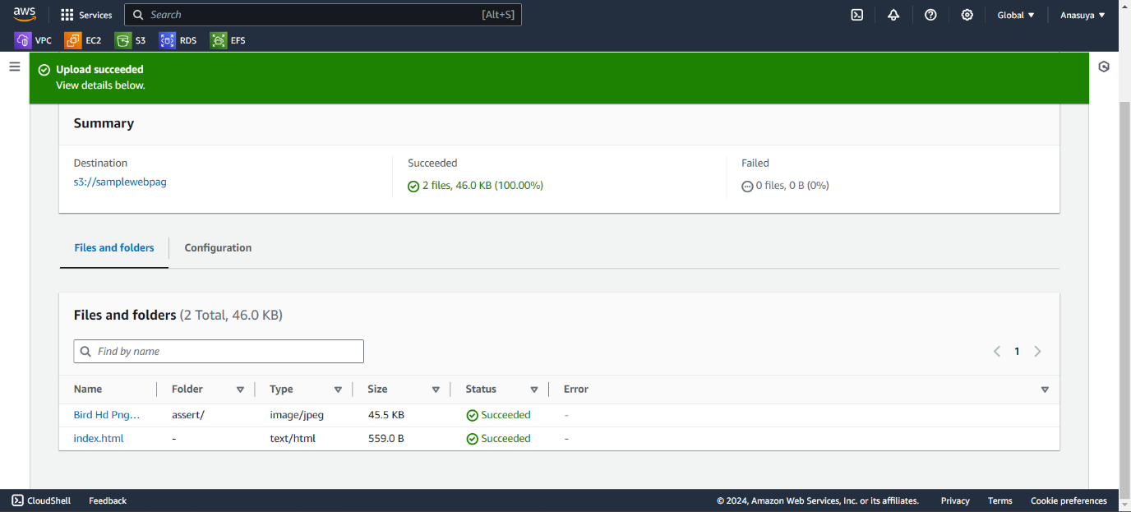

* In index.html file , copy the object URL and paste it in the browser to host the web application

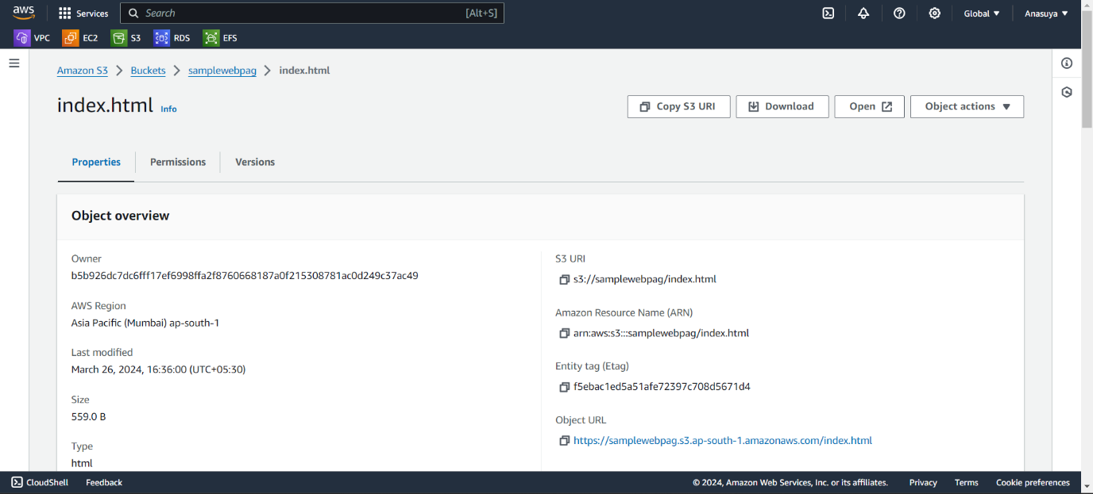

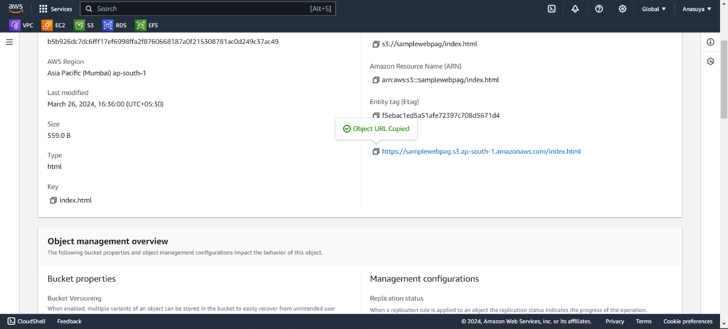

* Here it shows the error – Access denied. For that first go to bucket then click the properties, here the static web hosting is disabled , so edit and enable the static web hosting . And edit the name of index document and save the changes.

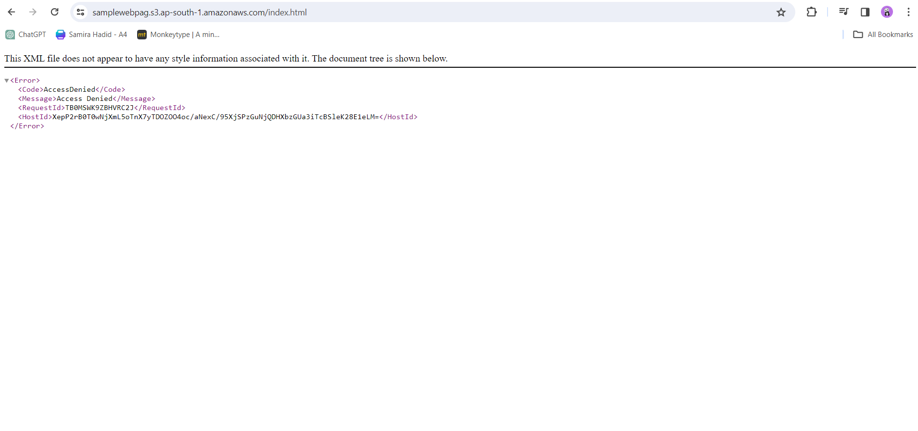

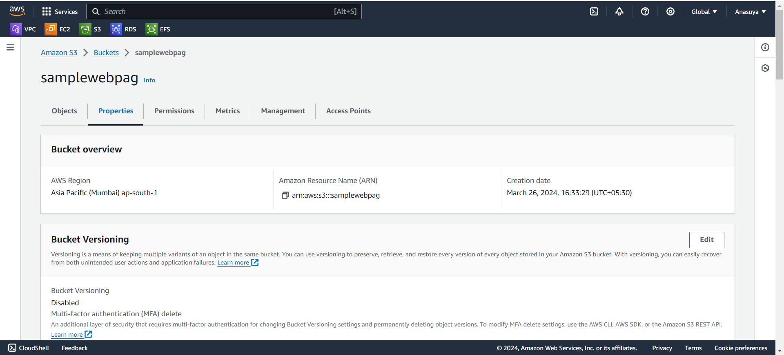

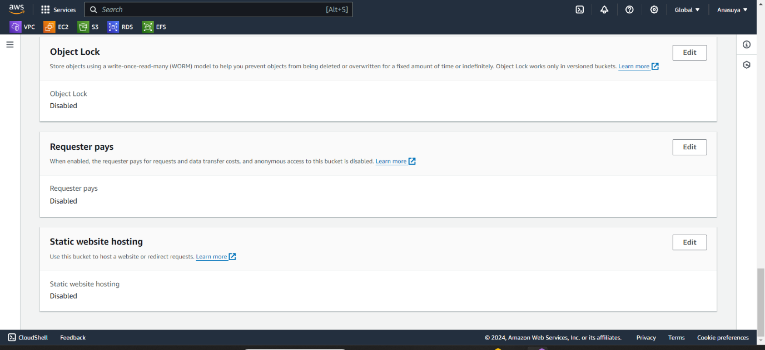

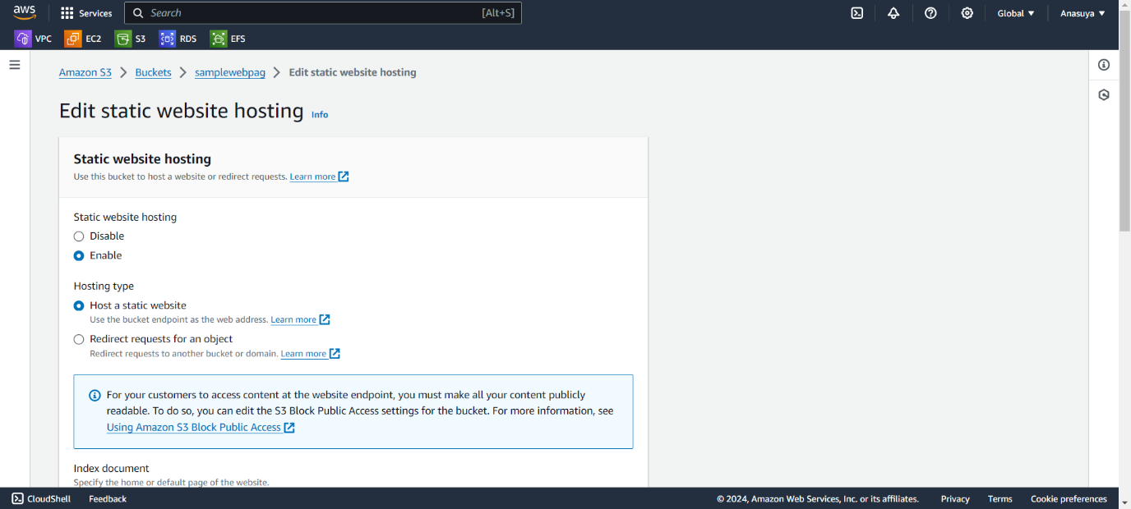

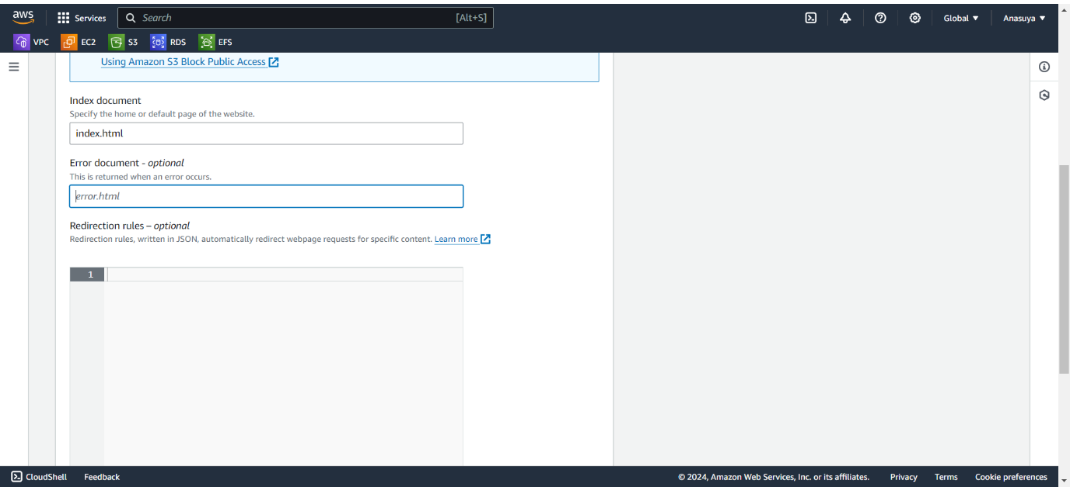

It will show like this after the changes

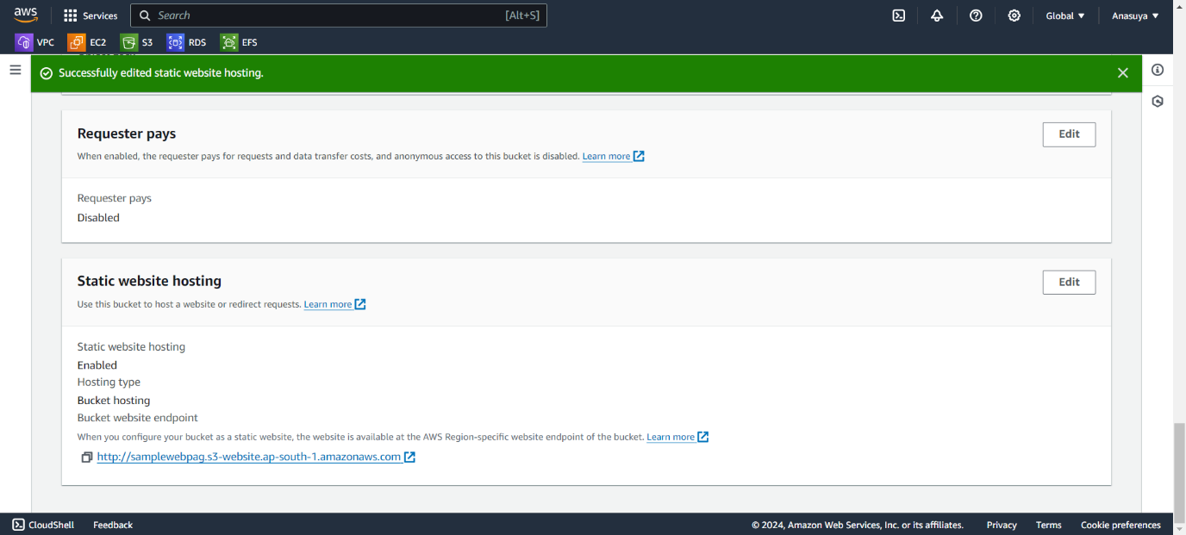

* Also edit the object ownership and enable the ACLs , then save the changes.

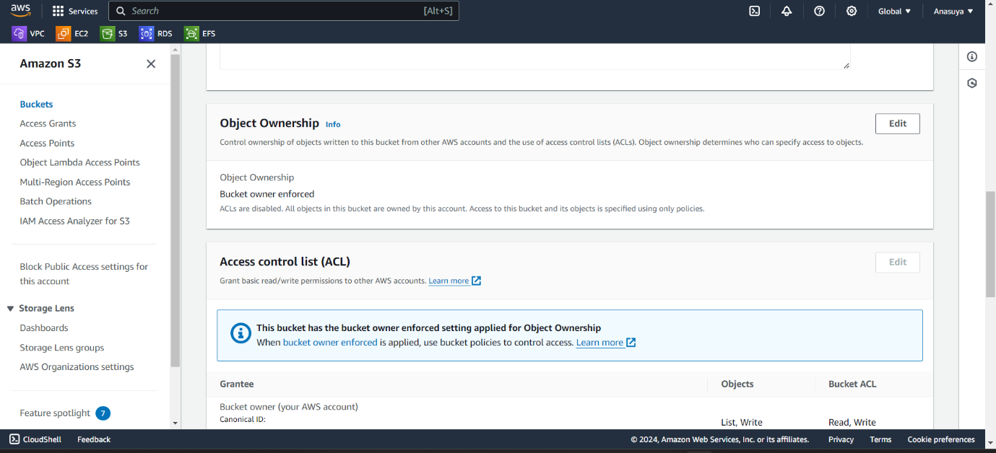

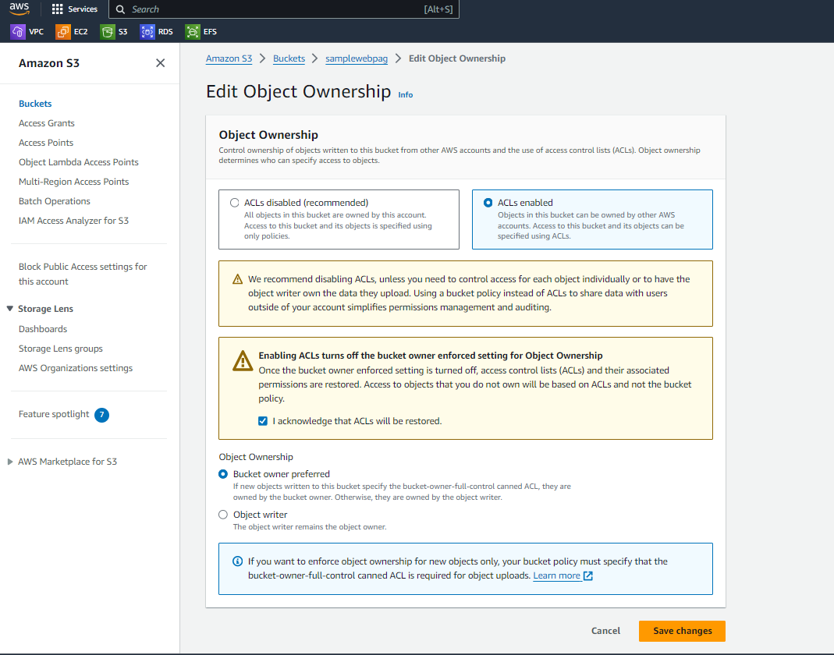

* Now go to object page and select the uploaded files then click the action , it shows the option to make public using ACL .

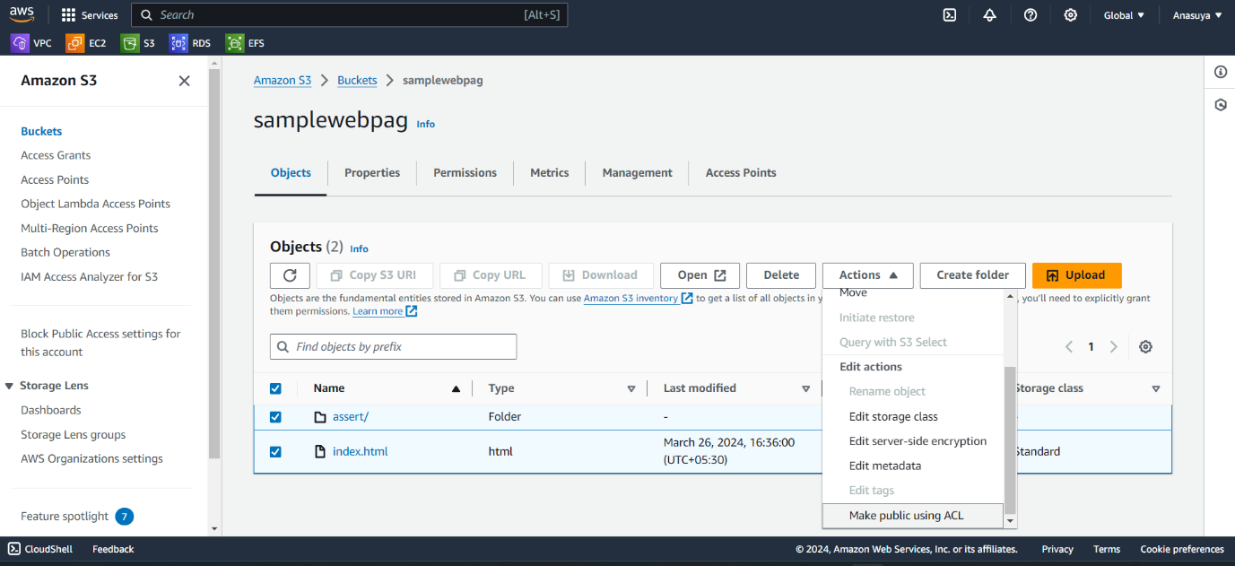

* Now Make it public

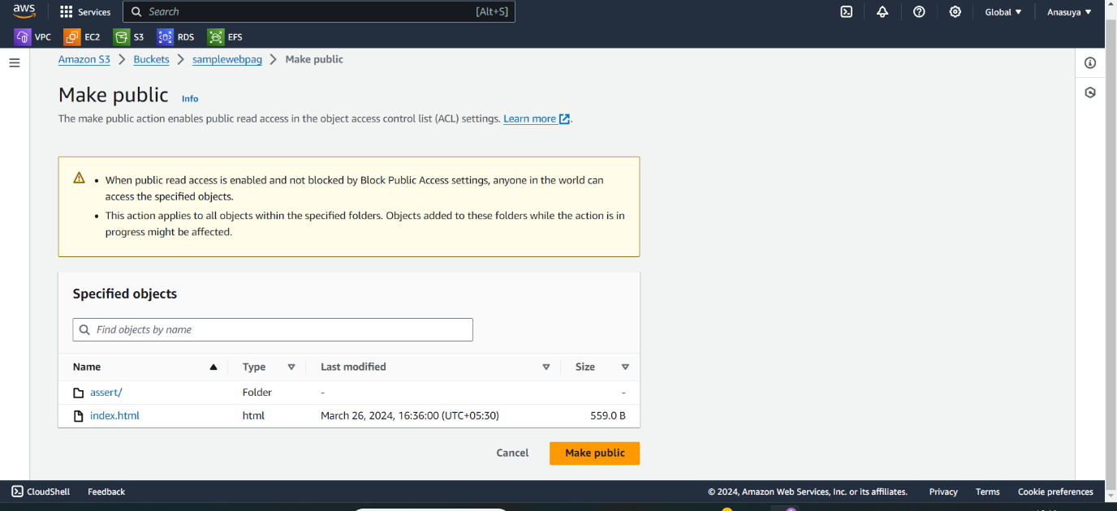

* Finally refresh the browser or copy and paste the object URL in the browser. Congratulations you have successfully hosting the web application from Amazon s3.

